Infonique

iSEB Expansion Board 1200 0012 V1.0

|  |  |  |
| --- | --- | --- |
| Prepared by | Date | Version |
| Bing Ran | 15/7/2023 | 1.0 |

# Abstract

This document provides detailed of Infonique iSEB Expansion Board 1200 0012 V1.0 specification.

# Document History

|  |  |  |  |
| --- | --- | --- | --- |
| **Date** | **Rev** | **Modifier** | **Changes** |
| **15-July-2023** | 1.0 | Bing Ran | First Draft |
|  |  |  |  |
|  |  |  |  |
|  |  |  |  |
|  |  |  |  |

# Contents

Abstract 2

Document History 2

Contents 3

Table of Figures 3

1 Introduction 4

2 Hardware 5

2.1 Schematic 5

2.2 Pinout 6

2.2 PCB Layout 7

2.2.1 Label of legs 8

2.2.2 PWM control 9

2.2.3 Switch , Battery Connector & RGB Led 11

2.3 Bom list 11

3 Firmware 12

3.1 Specification of the ESP32 DevKit V1 12

3.2 Environment set up 13

3.3 WiFi server and control 17

Table of Figures

Figure 1: Robot that controlled by iSEB Expansion Board 1200 0012 V1.0. 4

Figure 2: Schemaitc of iSEB Expansion Board 1200 0012 V1.0 5

Figure 3: iSEB Expansion Board 1200 0012 V1.0 with ESP32 Module 7

Figure 4: iSEB Expansion Board 1200 0012 V1.0 without ESP32 Module 7

Figure 5: Classification of legs and arms 8

Figure 6: PWM control port 9

Figure 7: ports for robot’s claws 10

Figure 8: Ports for robot's femurs 10

Figure 9: Switch , Battery connector & RGB led 11

Figure 10: Pinout of ESP32 DevKit V1 12

# 1 Introduction

This document will discuss the details of the iSEB Expansion Board 1200 0012 V1.0. iSEB Expansion Board 1200 0012 V1.0 is design for a spider robot. It provide 8 rgb leds and 16 pwm output to control the servo motors. The following figure is one of the robot that control with iSEB Expansion Board 1200 0012 V1.0.

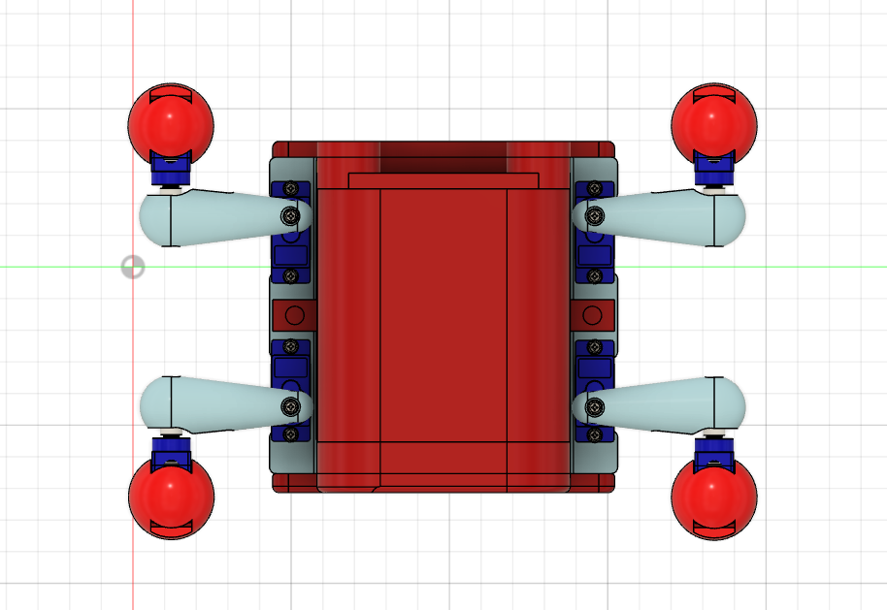

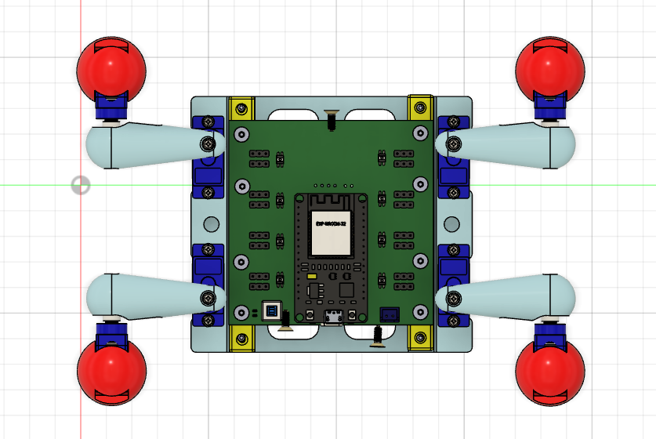Figure 1: Robot that controlled by iSEB Expansion Board 1200 0012 V1.0.

# 2 Hardware

## 2.1 Schematic

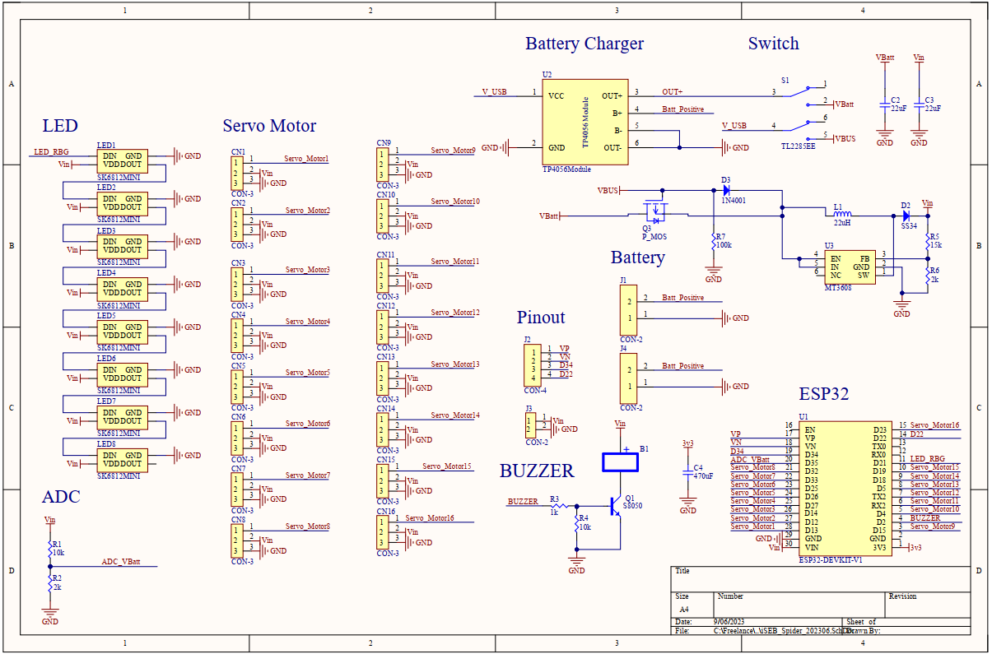

Figure 2: Schemaitc of iSEB Expansion Board 1200 0012 V1.0

## 2.2 Pinout

|  |  |  |  |
| --- | --- | --- | --- |
| **Pin** | **Function** | **Pin** | **Function** |
| EN | Enable Pin | D23 | PWM16 |
| VP | Unused | D22 | Unused |
| VN | Unused | TX0 | TX0 |
| D34 | Unused | RX0 | RX0 |
| D35 | ADC Vbatt | D21 | RGB Led |
| D32 | PWM8 | D19 | PWM15 |
| D33 | PWM7 | D18 | PWM14 |
| D25 | PWM6 | D05 | PWM13 |
| D26 | PWM5 | D17 | PWM12 |
| D27 | PWM4 | D16 | PWM11 |
| D14 | PWM3 | D04 | PWM10 |
| D12 | PWM2 | D02 | Buzzer |
| D13 | PWM1 | D15 | PWM9 |

Table 1: Pinout

## 2.2 PCB Layout

The following is the figure of the iSEB Expansion Board 1200 0012 V1.0

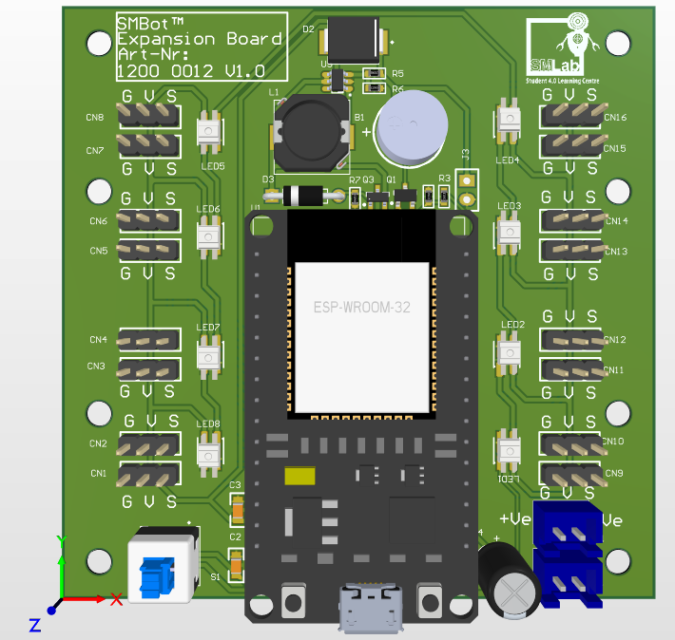

Figure 3: iSEB Expansion Board 1200 0012 V1.0 with ESP32 Module

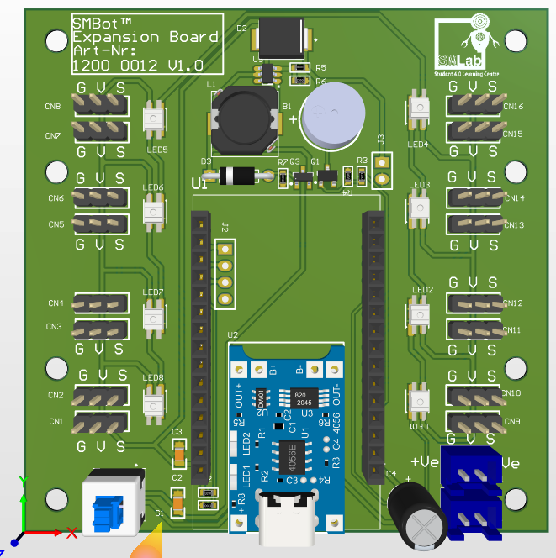

Figure 4: iSEB Expansion Board 1200 0012 V1.0 without ESP32 Module

## 2.2.1 Label of legs

The following figure is labeling the leg of the robot.

## 

Figure 5: Classification of legs and arms

## 2.2.2 PWM control

There are 16 PWM control port in iSEB Expansion Board 1200 0012 V1.0. The figure below is showing the locaiton of the 16 PWM control port.

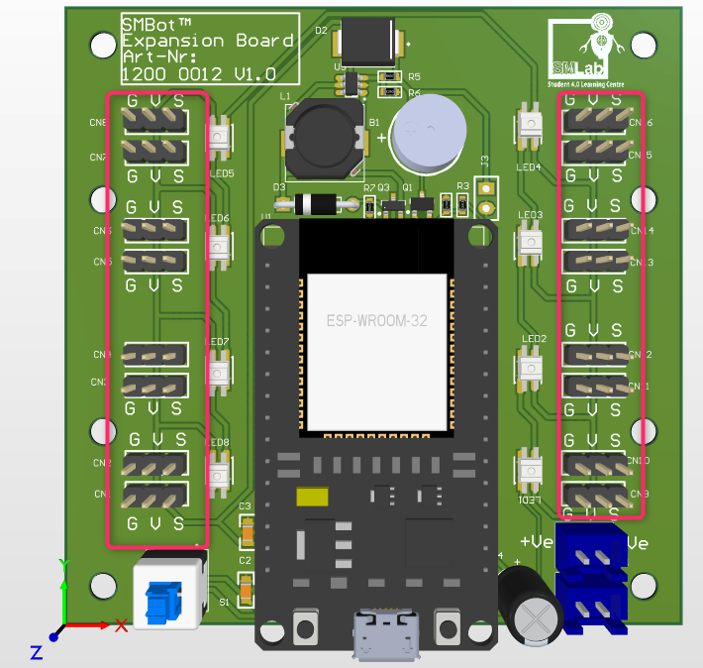

Figure 6: PWM control port

2.2.2.1 PWM Control Servo Motor Connection

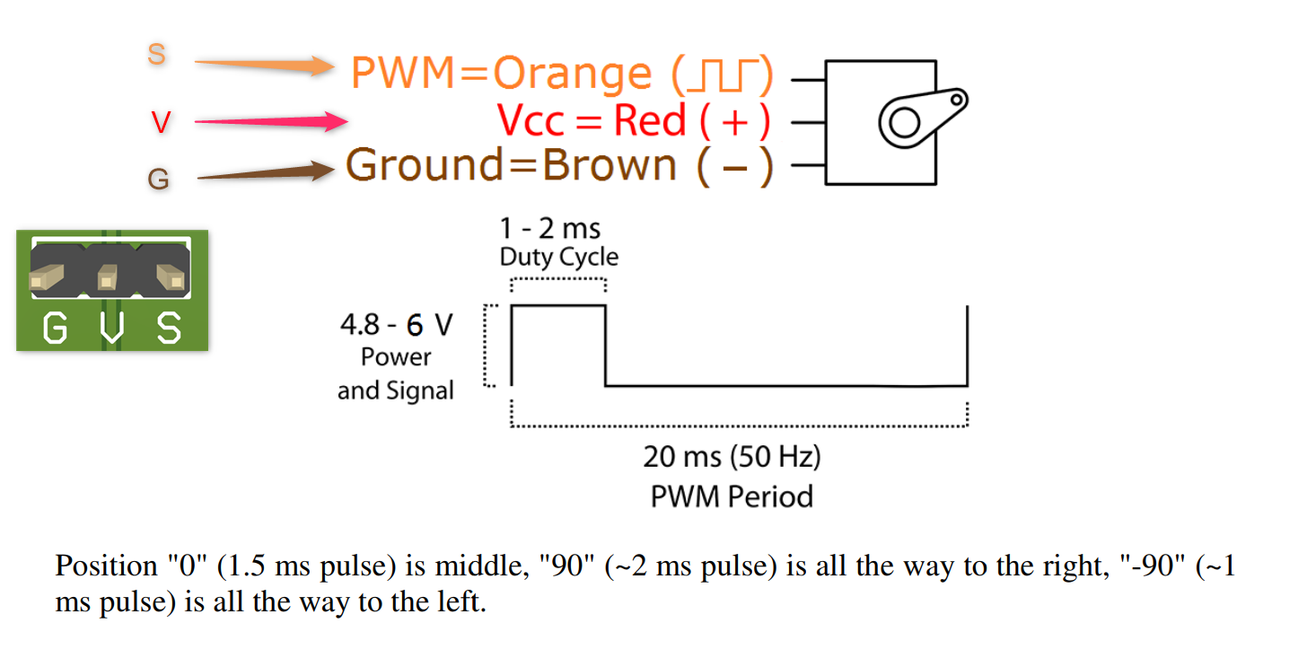

The figure below is specifying the port for each robot’s claw.

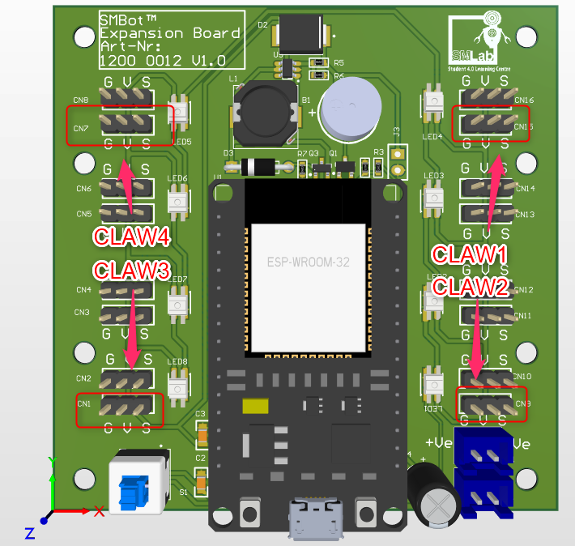Figure 7: ports for robot’s claws

The figure below is specifying the port for each robot’s femur.

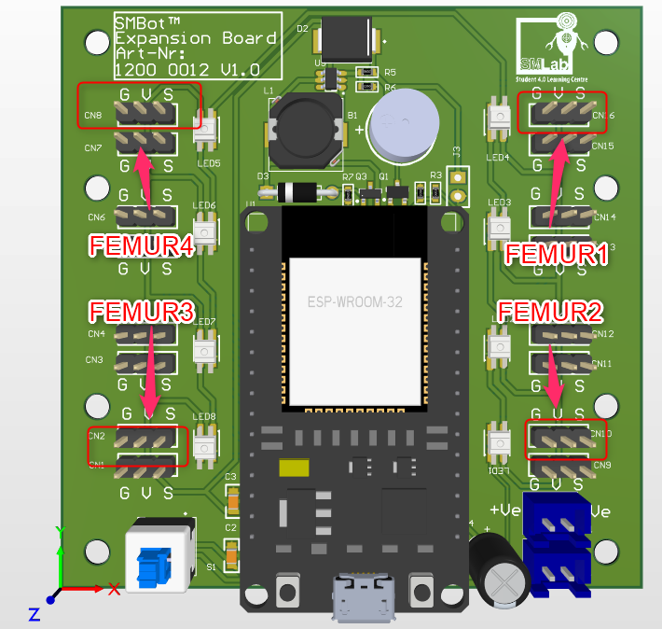

Figure 8: Ports for robot's femurs

## 2.2.3 Switch , Battery Connector & RGB Led

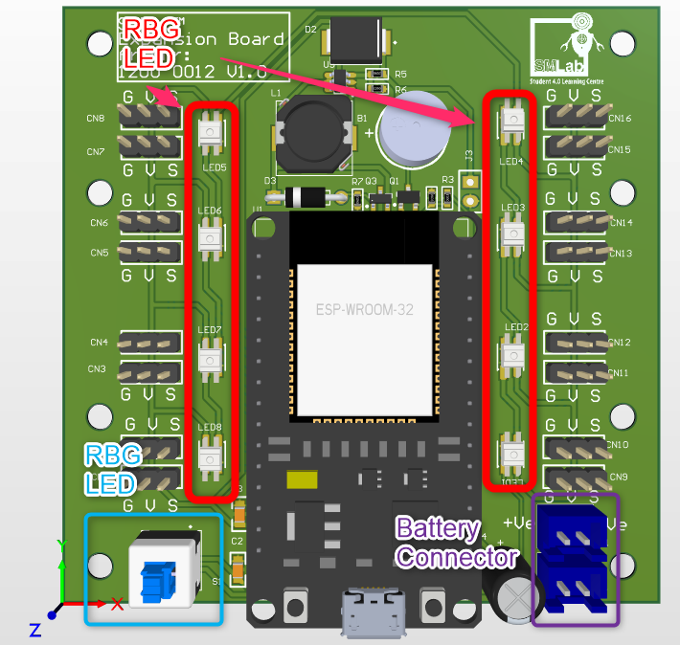Figure 9: Switch , Battery connector & RGB led

## 2.3 Bom list

* iSEB Expansion Board 1200 0012 V1.0 with ESP32 Module x 1
* 18650 Battery x 2
* ESP32-DEVKIT-V1 x 1
* Spider chassis set x 1

# 3 Firmware

The iSEB Expansion Board 1200 0012 V1.0 is using ESP32 DevKit V1. The figure is showing the pinout of ESP32 DevKit V1.The microcontroller is esp-wroom-32 module.

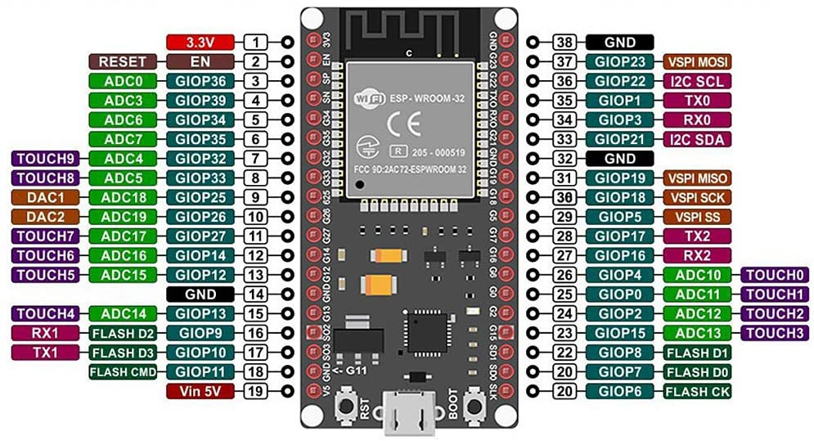Figure 10: Pinout of ESP32 DevKit V1

## 3.1 Specification of the ESP32 DevKit V1

Microcontroller: Tensilica 32-bit Single-/Dual-core CPU Xtensa LX6

* Operating Voltage: 3.3V
* Input Voltage: 7-12V
* Digital I/O Pins (DIO): 25
* Analog Input Pins (ADC): 6
* Analog Outputs Pins (DAC): 2
* UARTs: 3
* SPIs: 2
* I2Cs: 3
* Flash Memory: 4 MB
* SRAM: 520 KB
* Clock Speed: 240 Mhz
* Wi-Fi: IEEE 802.11 b/g/n/e/i:
  + Integrated TR switch, balun, LNA, power amplifier and matching network
  + WEP or WPA/WPA2 authentication, or open networks
* Dimensions: 51.5x29x5mm

## 3.2 Environment set up

We need to set up the environment to flash the binary to ESP32 DevKit V1.

* Install Arduino IDE is requried to install. ( Snapshot is base on Arduino IDE 2.2.0 )
* Add <https://raw.githubusercontent.com/espressif/arduino-esp32/gh-pages/package_esp32_index.json> to Board Managers and install ESP32 libary.
  + Select F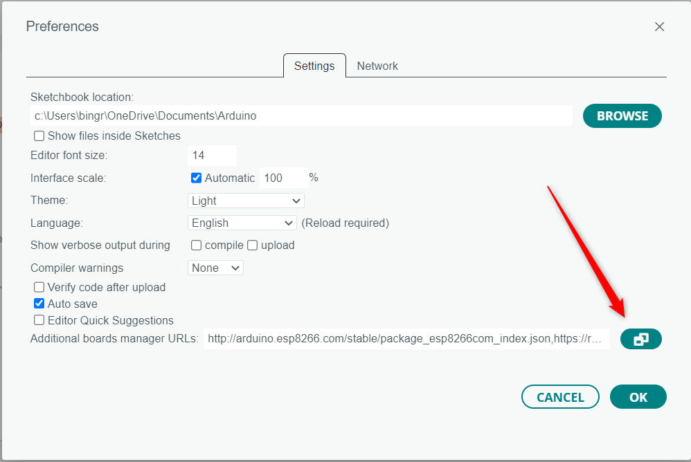iles-> Preferences and click on the icon
  + 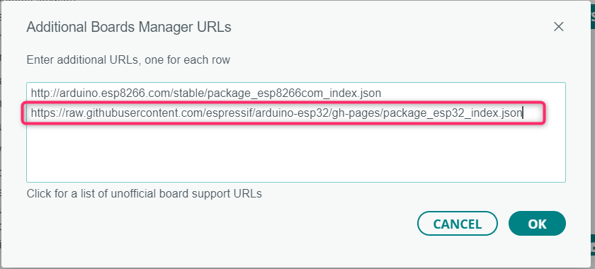Add Boards Manager URLs
  + Install ESP32 by Espressif Systems at Board Manager.

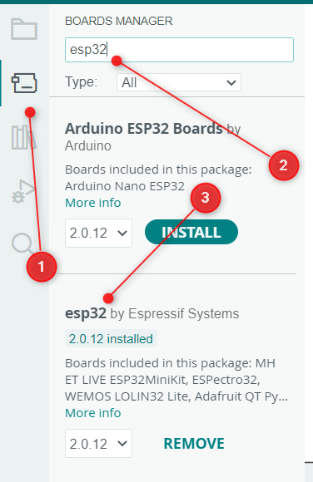

* Install WS2812FX by Harm Aldick ( version 1.4.2 ) library.
  + Snapshot of install libary

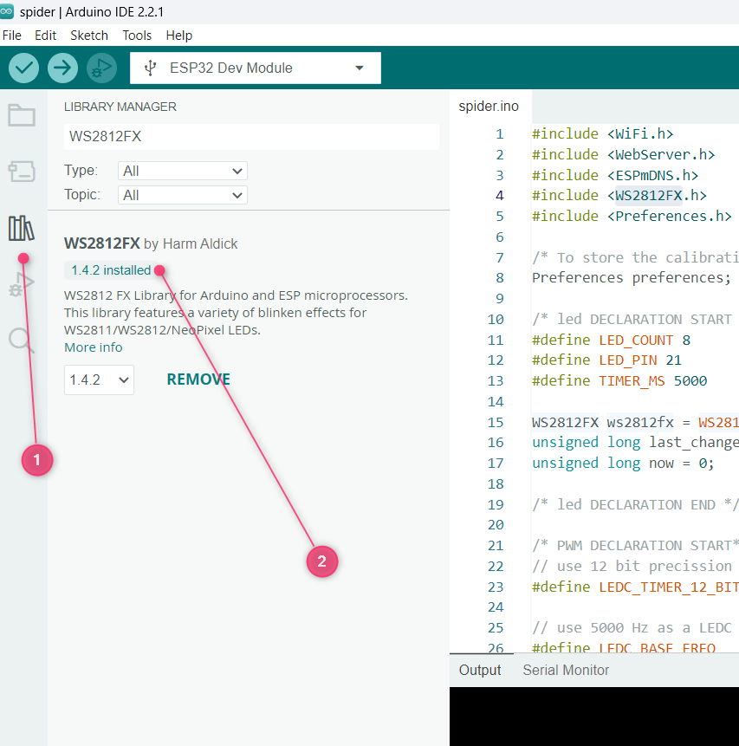

* Update the upload setting
  + 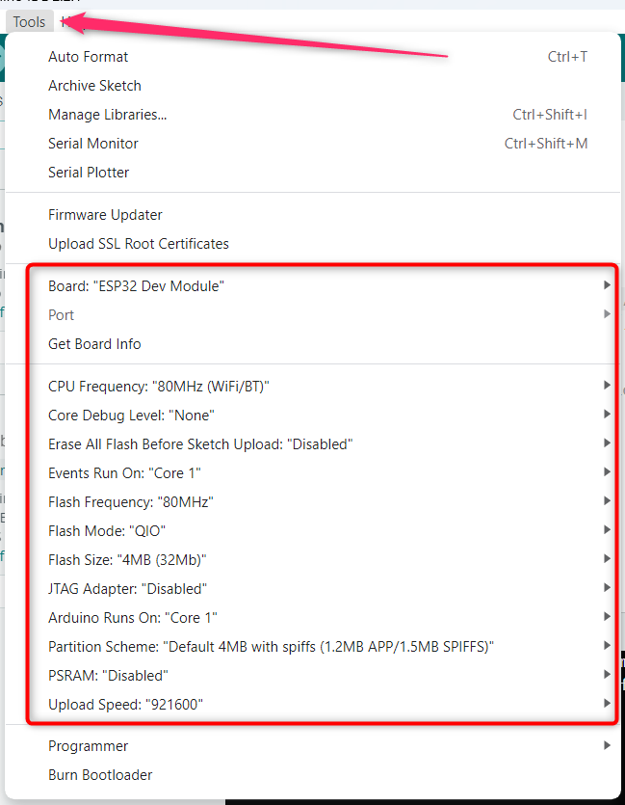
* Click upload button and the firmware will be flashed successfully if the snapshot below is seen.

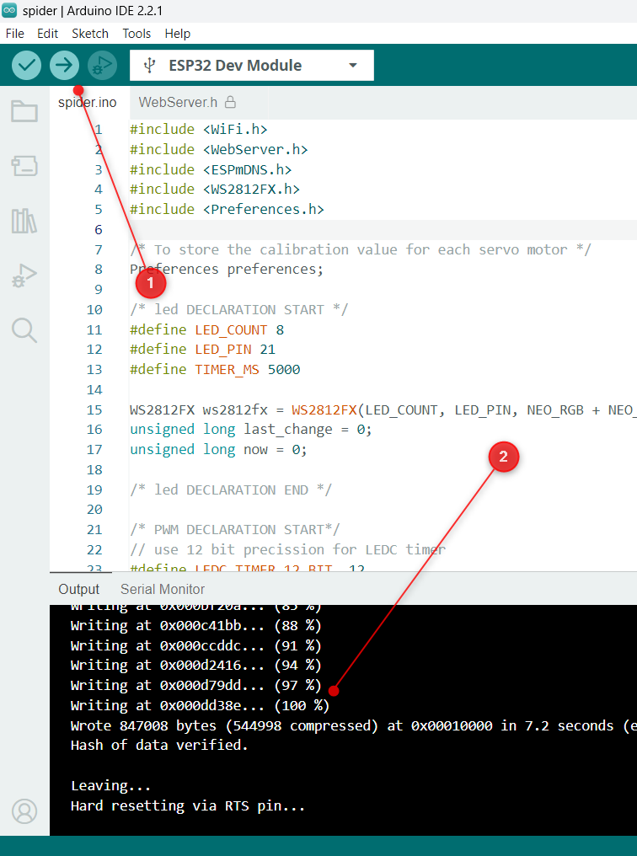

* The environment set up is done if the binary able to flash to ESP32 DevKit V1..

## 3.3 WiFi server and control

* After flash succesfully, the iSEB Spider should be appear in the WiFi list. The figure below is showing the iSEB spider is appeared in the WiFi list.

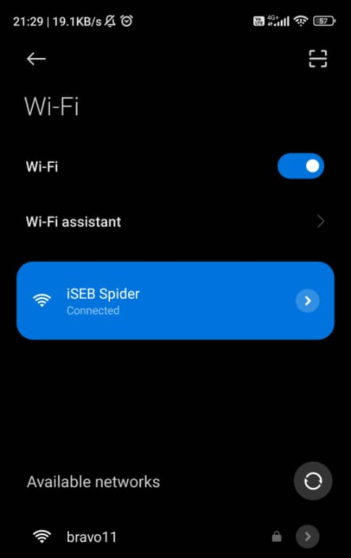

* Connect to the ISEB Spider and access 192.168.1.1

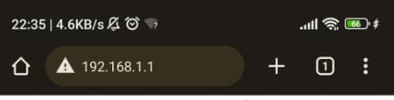

* The control page will be show as below

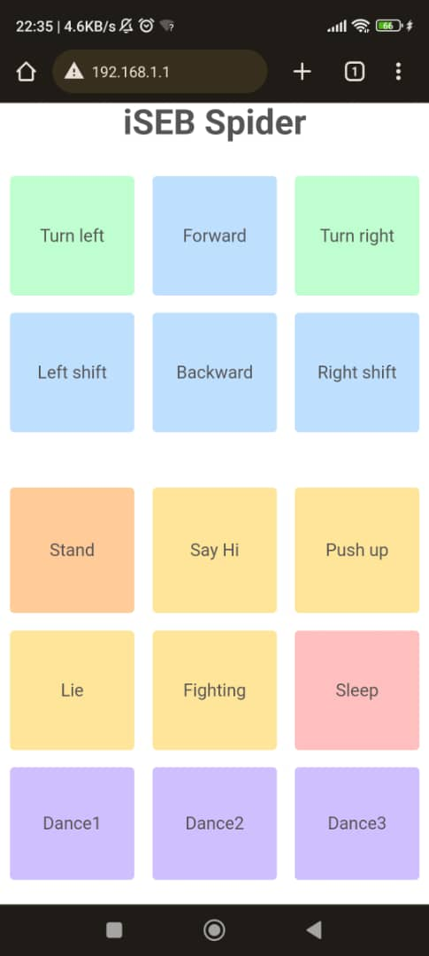

* The Motion Editor Page

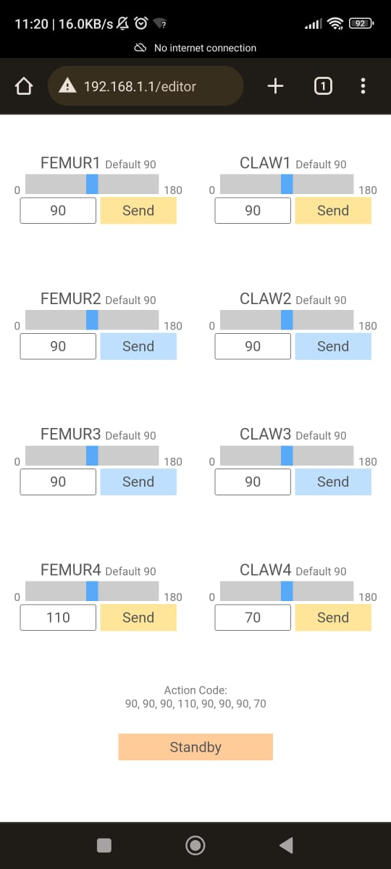

* The Zero Page

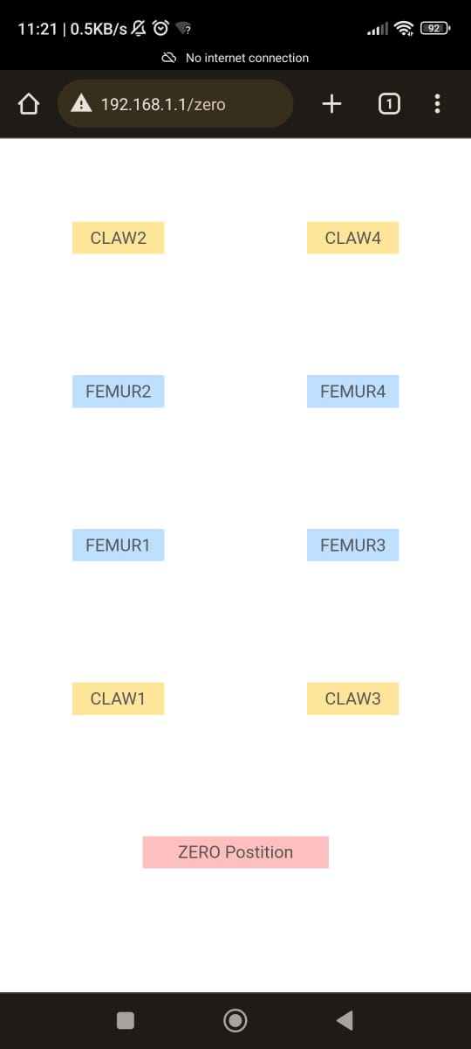

* The Setting page

